Prob -> Prepare the model to classify a glass type

Soln ->

> #KNN algos p1

> # predicting glass

> # Read the dataset

> glass <- read.csv(file.choose())

> View(glass)

> #First colum in dataset is id which is not required so we will be taking out

> #glass <- glass[-1]

>

>

> table(glass$Type)

1 2 3 5 6 7

70 76 17 13 9 29

>

> # Replace B with Benign and M with Malignant. Diagnosis is factor with 2 levels that is B and M. We also replacing these two entery with Benign and Malignat

> glass$Type <- factor(glass$Type)

>

> # table or proportation of enteries in the datasets. What % of entry is Bengin and % of entry is Malignant

> round(prop.table(table(glass$Type))*100,1)

1 2 3 5 6 7

32.7 35.5 7.9 6.1 4.2 13.6

>

> #Create a function to normalize the data

> norm <- function(x){

+ return((x-min(x))/(max(x)-min(x)))

+ }

>

> #we need to take random data splitting because the given data has output in sequence which will prove -

> #if we use sequential splitting

> train_index <- sample(1:nrow(glass), 0.7 * nrow(glass))

> test_index <- setdiff(1:nrow(glass), train_index)

>

> train<- glass[train_index,-10]

> train_label<-glass[train_index,"Type"]

>

> test<-glass[test_index,-10]

> test_label<-glass[test_index,"Type"]

>

> #Apply the normalization function

>

> train_n<-as.data.frame(lapply(train[1:9], norm))

> test_n<-as.data.frame(lapply(test[1:9], norm))

>

>

>

>

> # Build a KNN model on taining dataset

> library("class")

> # Building the KNN model on training dataset and also need labels which we are including c1. Once we build the preduction model

> # we have to test on test dataset

> test_acc <- NULL

> train_acc <- NULL

> for (i in seq(3,200,2))

+ {

+ train_glass_pred <- knn(train=train_n,test=train_n,cl=train_label,k=i)

+ train_acc <- c(train_acc,mean(train_glass_pred==train_label))

+ t_a<-c()

+ test_glass_pred <- knn(train = train_n, test = test_n, cl = train_label, k=i)

+ test_acc <- c(test_acc,mean(test_glass_pred==test_label))

+ }

There were 50 or more warnings (use warnings() to see the first 50)

>

>

> # Testing Accuracy

>

> # Plotting 2 different graphs on same window

> par(mfrow=c(1,2)) # c(1,2) => indicates 1 row and 2 columns

> plot(seq(3,200,2),train_acc,type="l",main="Train_accuracy",col="blue")

> plot(seq(3,200,2),test_acc,type="l",main="Test_accuracy",col="red")

> 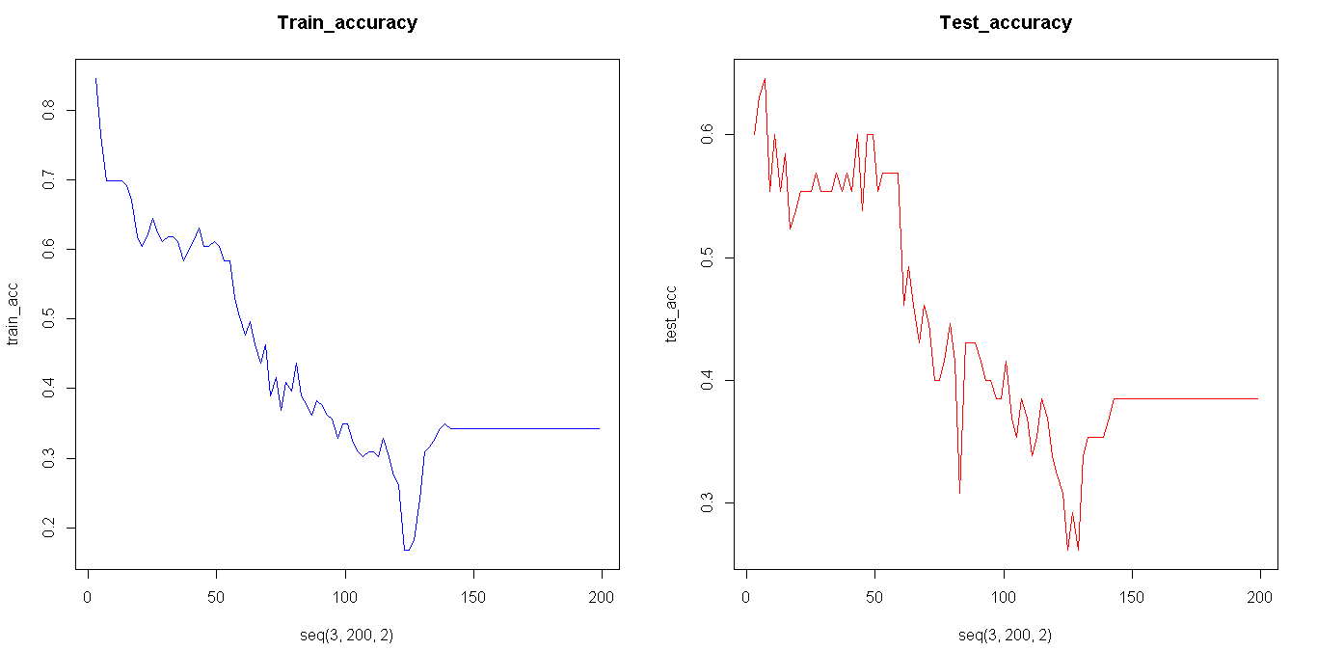

> acc_neigh_df <- data.frame(list(train_acc=train_acc,test_acc=test_acc,neigh=seq(3,200,2)))

> # Plotting 2 different graphs on same co-ordinate axis

> #install.packages("ggplot2")

> library(ggplot2)

> ggplot(acc_neigh_df,aes(x=neigh))+

+ geom_line(aes(y=train_acc,colour="train_acc"),lwd=1.5)+

+ geom_line(aes(y=test_acc,colour="test_acc"),lwd=1.5)+

+ scale_fill_manual(" ",breaks=c("train_acc","test_acc"),values = c("train_acc"="green","test_acc"="red"))

> 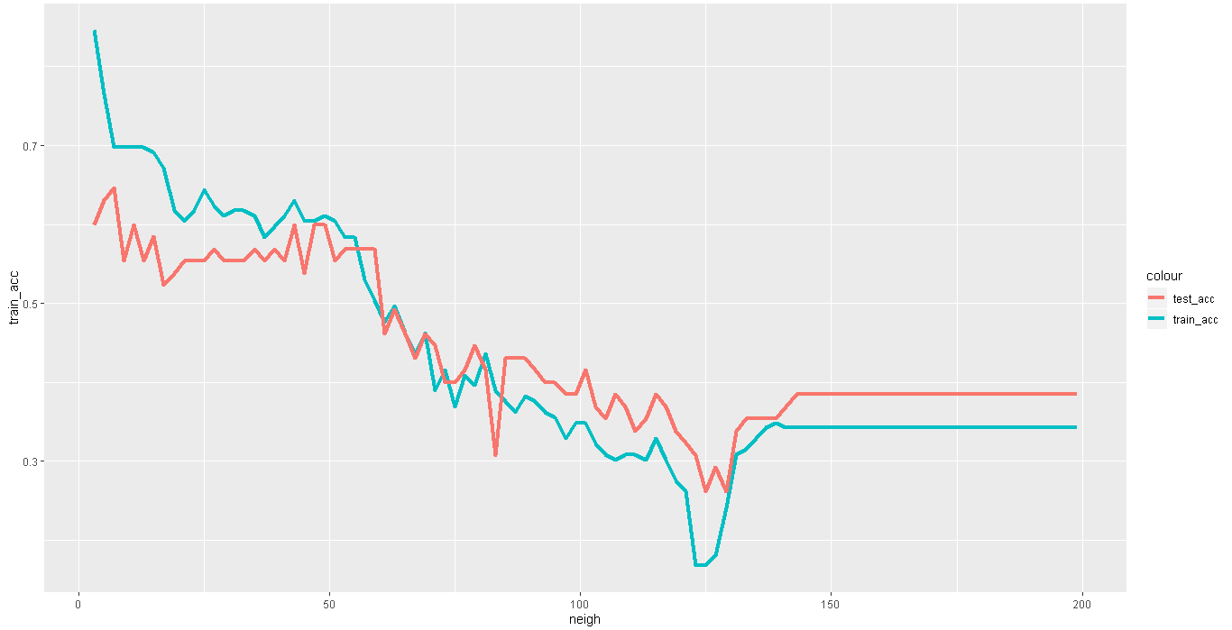

> #from the graph max accuracy can be acheved at k = 50

> glass_pred_te <- knn(train = train_n, test = test_n, cl = train_label, k=50)

> accuracy_test<- sum(glass_pred_te==test_label)/65

> glass_pred_tr <- knn(train = train_n, test = train_n, cl = train_label, k=50)

> accuracy_train<- sum(glass_pred_tr==train_label)/149

> accuracy_test

[1] 0.5846154

> accuracy_train

[1] 0.6107383

# model seems to be underfitting this problem can only be solved if we have high quantity and quality of observation

Prob 2 -> Prepare the model to classify the animal type

Soln ->

> #KNN zoo prob

>

> #KNN algos p1

> # predicting glass

> # Read the dataset

> zoo1 <- read.csv(file.choose())

> View(zoo1)

> #First colum in dataset is id which is not required so we will be taking out

> zoo<-zoo1[-1]

>

>

> table(zoo$type)

1 2 3 4 5 6 7

41 20 5 13 4 8 10

>

> #factorizing the type

> zoo$Type <- factor(zoo$type)

>

> # table or proportation of enteries in the datasets. What % of entry is Bengin and % of entry is Malignant

> round(prop.table(table(zoo$type))*100,1)

1 2 3 4 5 6 7

40.6 19.8 5.0 12.9 4.0 7.9 9.9

>

> #Create a function to normalize the data

> # norm <- function(x){

> # return((x-min(x))/(max(x)-min(x)))

> # }

>

> train_index <- sample(1:nrow(zoo), 0.7 * nrow(zoo))

> test_index <- setdiff(1:nrow(zoo), train_index)

>

> train<- zoo[train_index,-10]

> train_label<-zoo[train_index,"Type"]

>

> test<-zoo[test_index,-10]

> test_label<-zoo[test_index,"Type"]

>

>

>

> train_n<-train[1:17]

> test_n<-test[1:17]

>

>

>

>

> # Build a KNN model on taining dataset

> library("class")

> # Building the KNN model on training dataset and also need labels which we are including c1. Once we build the preduction model

> # we have to test on test dataset

> test_acc <- NULL

> train_acc <- NULL

> for (i in seq(3,200,2))

+ {

+ train_zoo_pred <- knn(train=train_n,test=train_n,cl=train_label,k=i)

+ train_acc <- c(train_acc,mean(train_zoo_pred==train_label))

+ t_a<-c()

+ test_zoo_pred <- knn(train = train_n, test = test_n, cl = train_label, k=i)

+ test_acc <- c(test_acc,mean(test_zoo_pred==test_label))

+ }

There were 50 or more warnings (use warnings() to see the first 50)

>

>

> # Testing Accuracy

>

> # Plotting 2 different graphs on same window

> par(mfrow=c(1,2)) # c(1,2) => indicates 1 row and 2 columns

> plot(seq(3,200,2),train_acc,type="l",main="Train_accuracy",col="blue")

> plot(seq(3,200,2),test_acc,type="l",main="Test_accuracy",col="red")

> 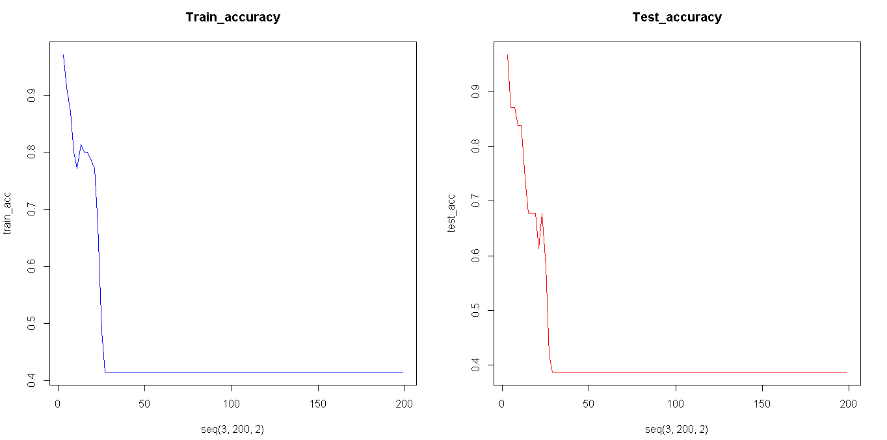

> acc_neigh_df <- data.frame(list(train_acc=train_acc,test_acc=test_acc,neigh=seq(3,200,2)))

> # Plotting 2 different graphs on same co-ordinate axis

> #install.packages("ggplot2")

> library(ggplot2)

> ggplot(acc_neigh_df,aes(x=neigh))+

+ geom_line(aes(y=train_acc,colour="train_acc"),lwd=1.5)+

+ geom_line(aes(y=test_acc,colour="test_acc"),lwd=1.5)+

+ scale_fill_manual(" ",breaks=c("train_acc","test_acc"),values = c("train_acc"="green","test_acc"="red"))

> 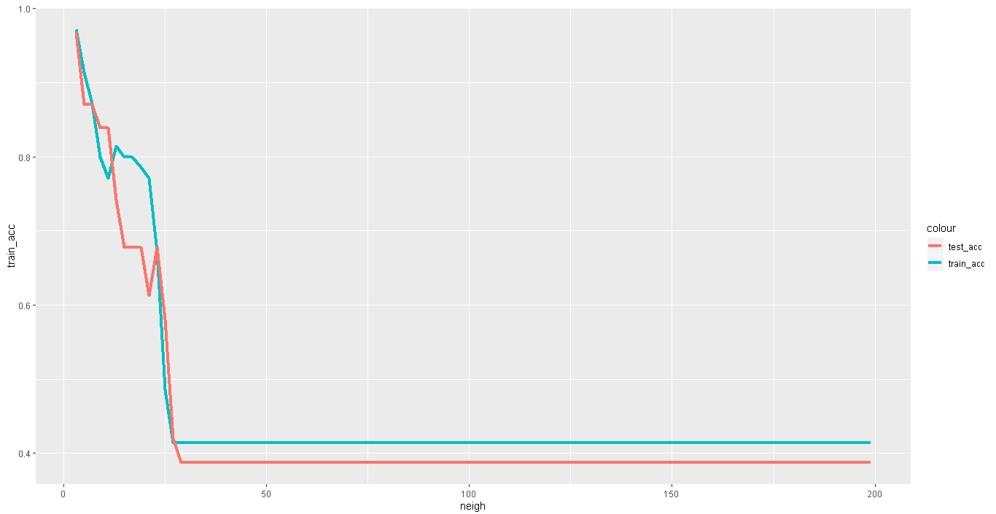

> #from the graph max accuracy can be acheved at k = 4

> zoo_pred_te <- knn(train = train_n, test = test_n, cl = train_label, k=4)

> accuracy_test<- sum(zoo_pred_te==test_label)/31

> zoo_pred_tr <- knn(train = train_n, test = train_n, cl = train_label, k=4)

> accuracy_train<- sum(zoo_pred_tr==train_label)/70

> accuracy_test

[1] 0.9354839

> accuracy_train

[1] 0.9428571